**QUESTION 1: Plotting different bar graphs using R**

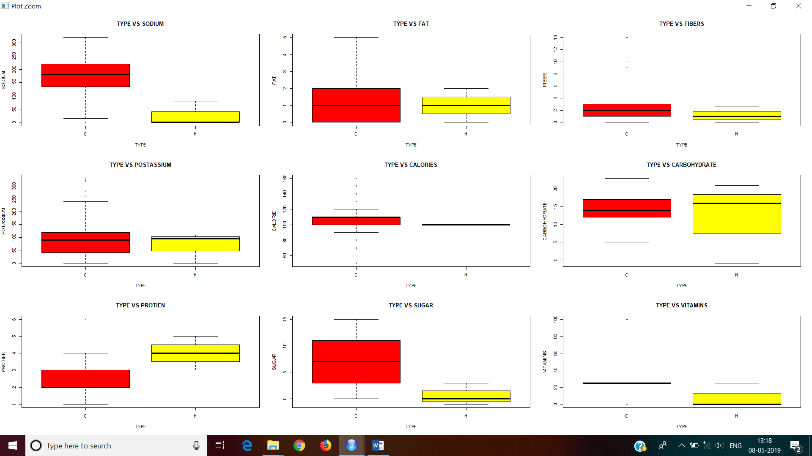

par(mfcol=c(3,3))

plot(cereal_breakfast$sodium~cereal_breakfast$type,data=cereal_breakfast,xlab="TYPE",ylab="SODIUM",main="TYPE VS SODIUM",col=c("red","yellow"))

plot(cereal_breakfast$potass~cereal_breakfast$type,data=cereal_breakfast,xlab="TYPE",ylab="POTASSIUM",main="TYPE VS POSTASSIUM",col=c("red","yellow"))

plot(cereal_breakfast$protein~cereal_breakfast$type,data=cereal_breakfast,xlab="TYPE",ylab="PROTIEN",main="TYPE VS PROTIEN",col=c("red","yellow"))

plot(cereal_breakfast$fat~cereal_breakfast$type,data=cereal_breakfast,xlab="TYPE",ylab="FAT",main="TYPE VS FAT",col=c("red","yellow"))

plot(cereal_breakfast$calories~cereal_breakfast$type,data=cereal_breakfast,xlab="TYPE",ylab="CALORIE",main="TYPE VS CALORIES",col=c("red","yellow"))

plot(cereal_breakfast$sugars~cereal_breakfast$type,data=cereal_breakfast,xlab="TYPE",ylab="SUGAR",main="TYPE VS SUGAR",col=c("red","yellow"))

plot(cereal_breakfast$fiber~cereal_breakfast$type,data=cereal_breakfast,xlab="TYPE",ylab="FIBER",main="TYPE VS FIBERS",col=c("red","yellow"))

plot(cereal_breakfast$carbo~cereal_breakfast$type,data=cereal_breakfast,xlab="TYPE",ylab="CARBOHYDRATE",main="TYPE VS CARBOHYDRATE",col=c("red","yellow"))

plot(cereal_breakfast$vitamins~cereal_breakfast$type,data=cereal_breakfast,xlab="TYPE",ylab="VITAMINS",main="TYPE VS VITAMINS",col=c("red","yellow"))

**QUESTION 2: Pie chart for different essentials elements of breakfast along with mean, mode, median, standard deviation and variance.**

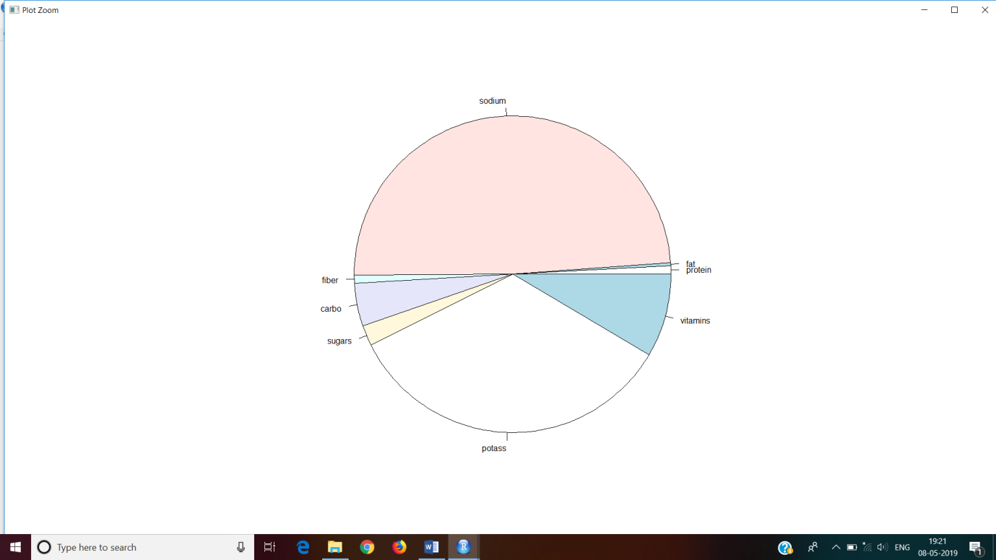

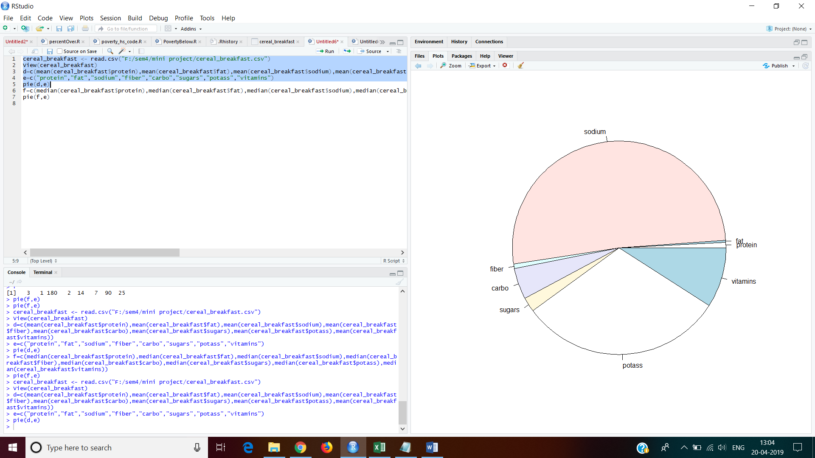

**mean**

d=c(mean(cereal_breakfast$protein),mean(cereal_breakfast$fat),mean(cereal_breakfast$sodium),mean(cereal_breakfast$fiber),mean(cereal_breakfast$carbo),mean(cereal_breakfast$sugars),mean(cereal_breakfast$potass),mean(cereal_breakfast$vitamins))

e=c("protein","fat","sodium","fiber","carbo","sugars","potass","vitamins")

pie(d,e)

Median

e=c("protein","fat","sodium","fiber","carbo","sugars","potass","vitamins")

f=c(median(cereal_breakfast$protein),median(cereal_breakfast$fat),median(cereal_breakfast$sodium),median(cereal_breakfast$fiber),median(cereal_breakfast$carbo),median(cereal_breakfast$sugars),median(cereal_breakfast$potass),median(cereal_breakfast$vitamins))

pie(f,e)

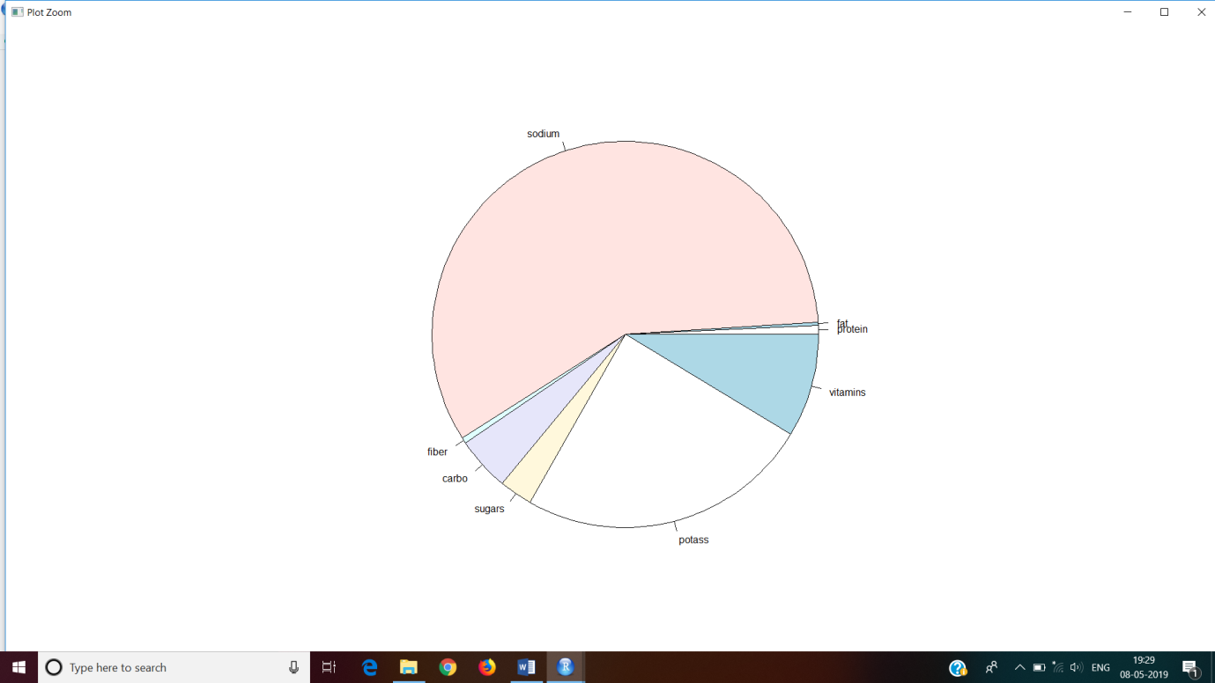

**Mode**

e=c("protein","fat","sodium","fiber","carbo","sugars","potass","vitamins")

getmode<- function(v)

{

uniqv<-unique(v)

uniqv[which.max(tabulate(match(v,uniqv)))]

}

g=c(getmode(cereal_breakfast$protein),getmode(cereal_breakfast$fat),getmode(cereal_breakfast$sodium),getmode(cereal_breakfast$fiber),getmode(cereal_breakfast$carbo),getmode(cereal_breakfast$sugars),getmode(cereal_breakfast$potass),getmode(cereal_breakfast$vitamins))

pie(g,e)

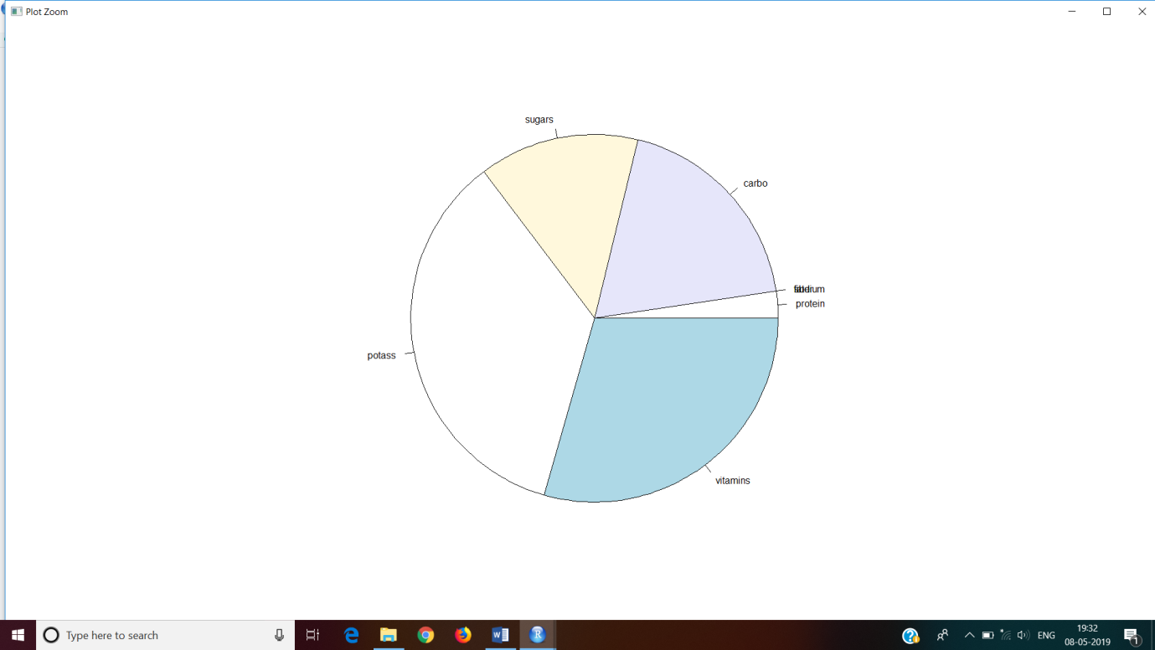

**Standard deviation**

e=c("protein","fat","sodium","fiber","carbo","sugars","potass","vitamins")

h=c(sd(cereal_breakfast$protein),sd(cereal_breakfast$fat),sd(cereal_breakfast$sodium),sd(cereal_breakfast$fiber),sd(cereal_breakfast$carbo),sd(cereal_breakfast$sugars),sd(cereal_breakfast$potass),sd(cereal_breakfast$vitamins))

pie(h,e)

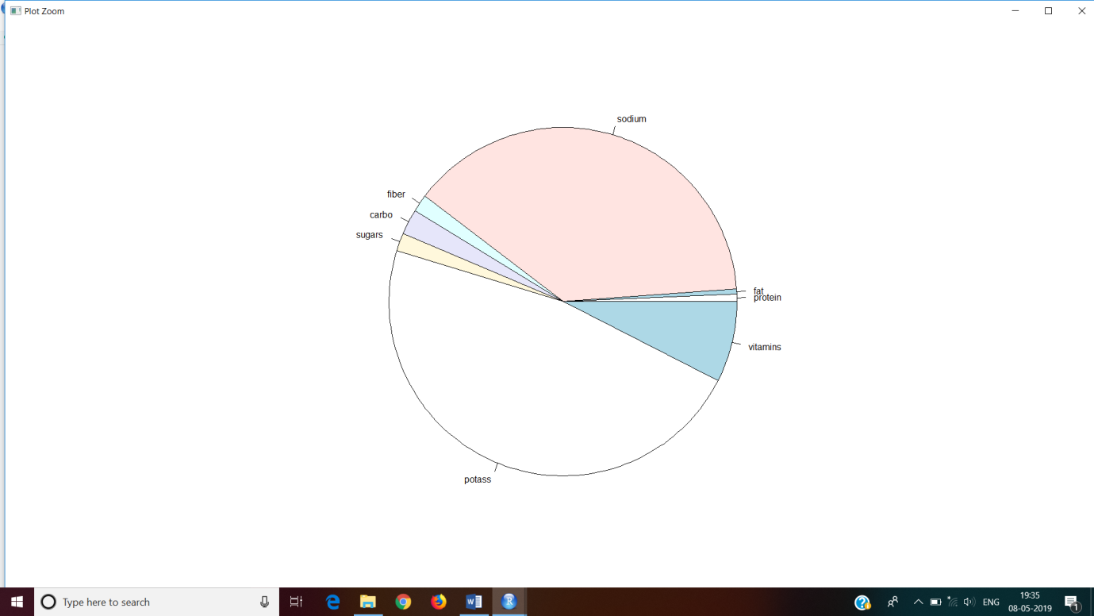

**Variance**

e=c("protein","fat","sodium","fiber","carbo","sugars","potass","vitamins")

i=c(var(cereal_breakfast$protein),var(cereal_breakfast$fat),var(cereal_breakfast$sodium),var(cereal_breakfast$fiber),var(cereal_breakfast$carbo),var(cereal_breakfast$sugars),var(cereal_breakfast$potass),var(cereal_breakfast$vitamins))

pie(i,e)

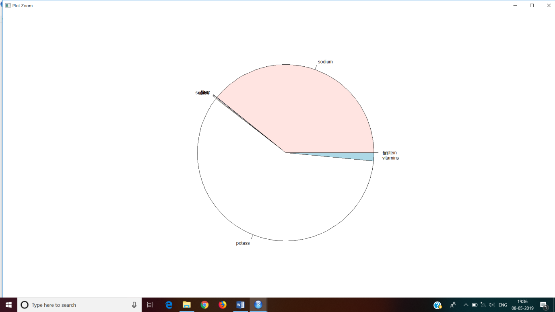

**QUESTION3: To standardize the dataset to make it simpler to analyze.**

cereal_breakfast$sodium = cereal_breakfast$sodium/cereal_breakfast$cups

cereal_breakfast$fat = cereal_breakfast$fat/cereal_breakfast$cups

cereal_breakfast$fiber = cereal_breakfast$fiber/cereal_breakfast$cups

cereal_breakfast$carbo = cereal_breakfast$carbo/cereal_breakfast$cups

cereal_breakfast$sugars = cereal_breakfast$sugars/cereal_breakfast$cups

cereal_breakfast$potass = cereal_breakfast$potass/cereal_breakfast$cups

cereal_breakfast$vitamins = cereal_breakfast$vitamins/cereal_breakfast$cups

cereal_breakfast$protein = cereal_breakfast$protein/cereal_breakfast$cups

cereal_breakfast$calories= cereal_breakfast$calories/cereal_breakfast$cups

cereal_breakfast$cups=1

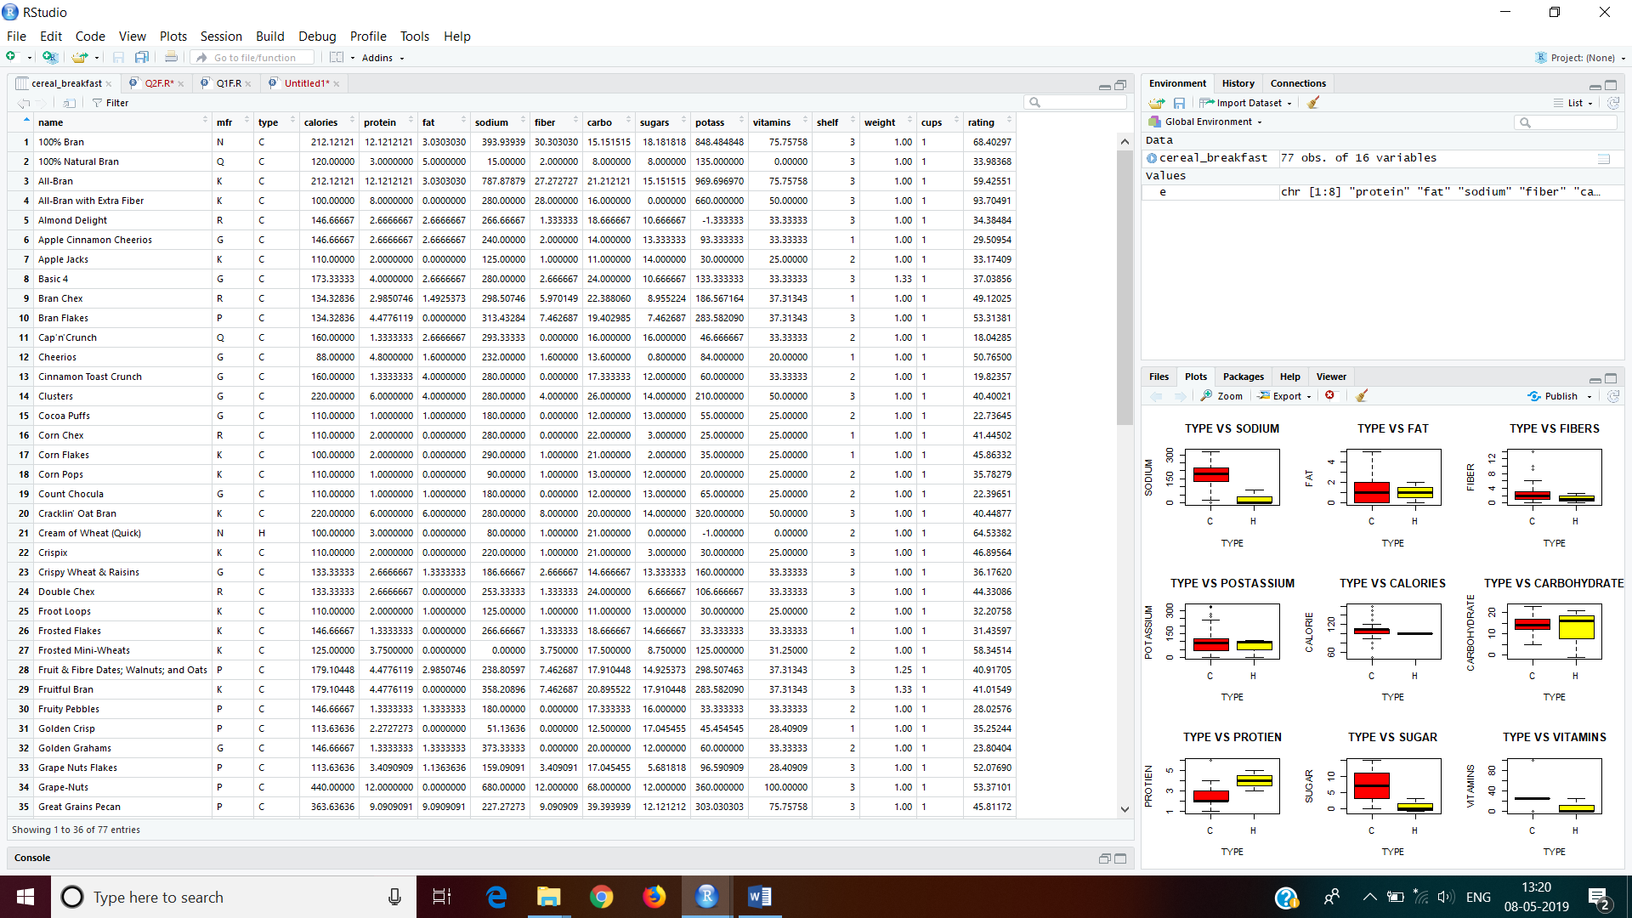

**QUESTION 4: Box plotting various elements to find which element is essential.**

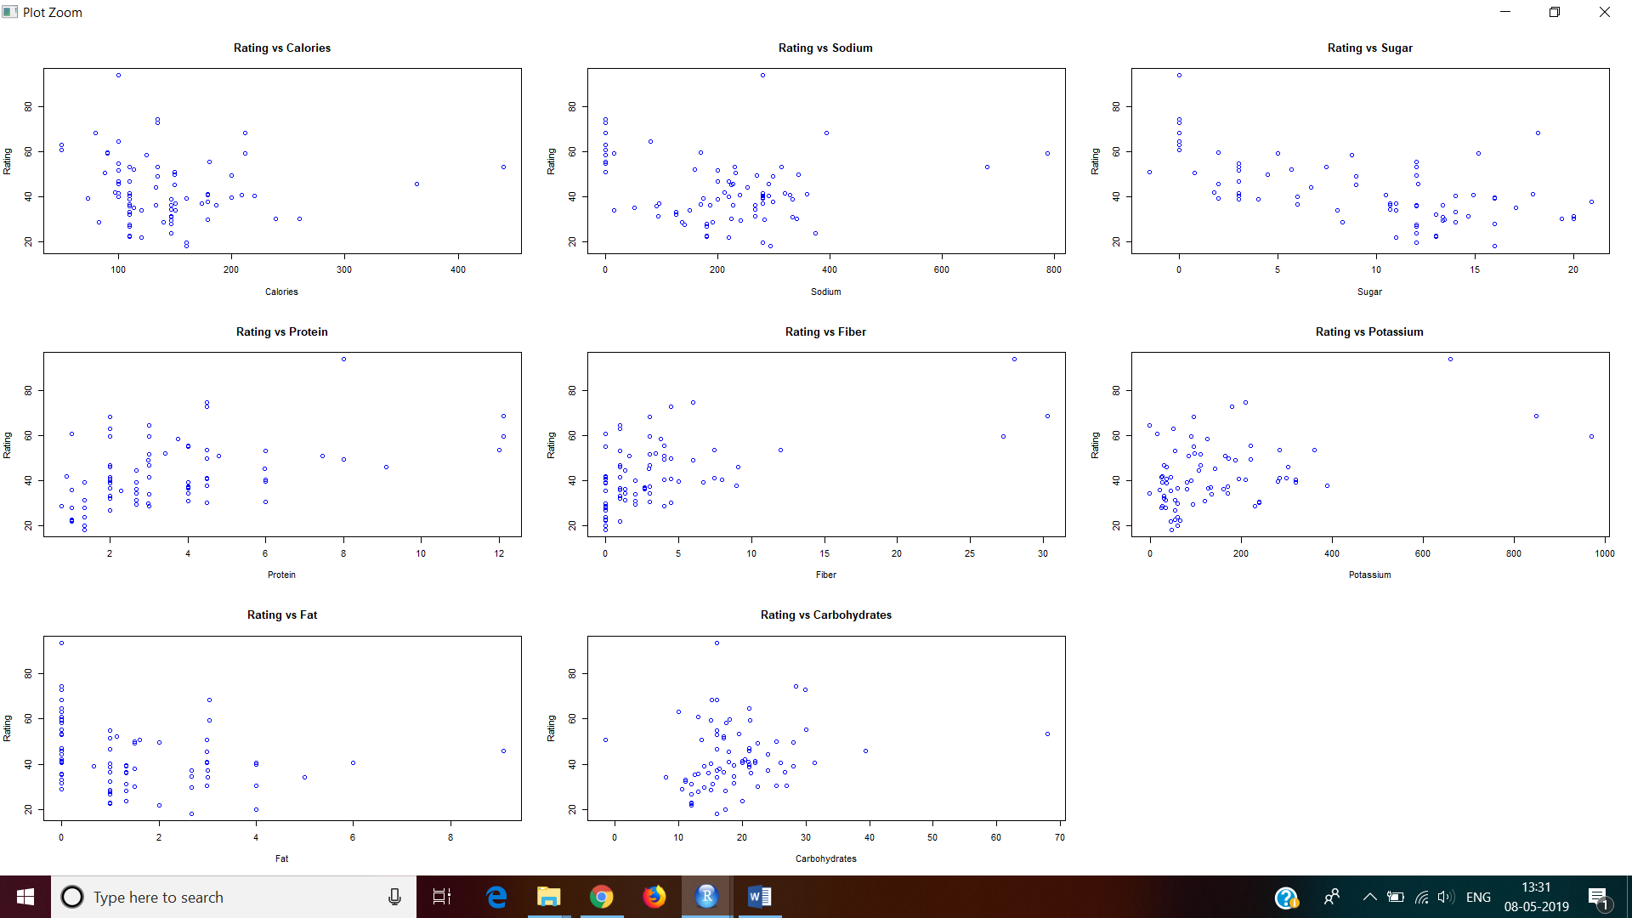

#Plots for rating vs various variables

par(mfcol=c(3,3))

#rating vs calories

plot(cereal_breakfast$rating~calories, data = cereal_breakfast, xlab="Calories", ylab="Rating",

main="Rating vs Calories",col="blue")

#rating vs protein

plot(cereal_breakfast$rating~protein, data = cereal_breakfast, xlab="Protein", ylab="Rating",

main="Rating vs Protein", col="blue")

#rating vs fat

plot(cereal_breakfast$rating~fat, data = cereal_breakfast, xlab="Fat", ylab="Rating", main="Rating

vs Fat", col="blue")

#rating vs sodium

plot(cereal_breakfast$rating~sodium,data = cereal_breakfast, xlab="Sodium", ylab="Rating",

main="Rating vs Sodium",col="blue")

#rating vs fiber

plot(cereal_breakfast$rating~fiber, data = cereal_breakfast, xlab="Fiber", ylab="Rating",

main="Rating vs Fiber",col="blue")

#rating vs carbo

plot(cereal_breakfast$rating~carbo, data = cereal_breakfast, xlab="Carbohydrates", ylab="Rating",

main="Rating vs Carbohydrates",col="blue")

#rating vs sugars

plot(cereal_breakfast$rating~sugars, data = cereal_breakfast, xlab="Sugar", ylab="Rating",

main="Rating vs Sugar", col="blue")

#rating vs potass

plot(cereal_breakfast$rating~potass, data = cereal_breakfast,xlab="Potassium", ylab="Rating",

main="Rating vs Potassium",col="blue")

#rating vs vitamins

boxplot(rating~vitamins, data = cp, xlab="Vitamins",ylab="Ratings", main="Rating vs Vitamins",

col=c("red","green","blue"))